Date | 28.09.2026
Team ID | SWTID-2026-6482
Project Name | Auto Ticket Classification using Flow Designer

Project Designing Phase-III

1) Proposed Solution

Problem Summary
The school IT helpdesk receives multiple incident requests daily from students and teachers, such as Wi-Fi issues, projector failures, password problems, and slow computers.
Currently, IT staff manually reviews each request and assigns a category, which is time-consuming and inefficient.

Proposed Solution - Overview
When a student creates a new IT support ticket, they only need to enter the Caller Name and Short Description of the issue. The student does not need to manually select the Category or Subcategory.
Once the ticket is submitted, a Flow Designer automation is triggered and evaluates the Short Description for predefined keywords such as WiFi, Projector, Password, or Slow. Based on the identified keyword, the flow automatically assigns the appropriate Category and Subcategory to the ticket.
• If the short description contains the word WiFi, the flow assigns Category = Network and Subcategory = WiFi.
• If the description contains Projector, the flow assigns Category = Hardware and Subcategory = Projector.
• If the description includes Password or Login, the flow assigns Category = Access and Subcategory = Forgot Password.
• If the description mentions Slow or Hanging, the flow assigns Category = Performance and Subcategory = Slow Computer.
This automation ensures consistent classification, eliminates human error, and significantly reduces manual effort required by IT staff.
The entire process is implemented using Flow Designer, making solution easy to maintain, scalable, and completely no-code.

Proposed Solution Flow Diagram
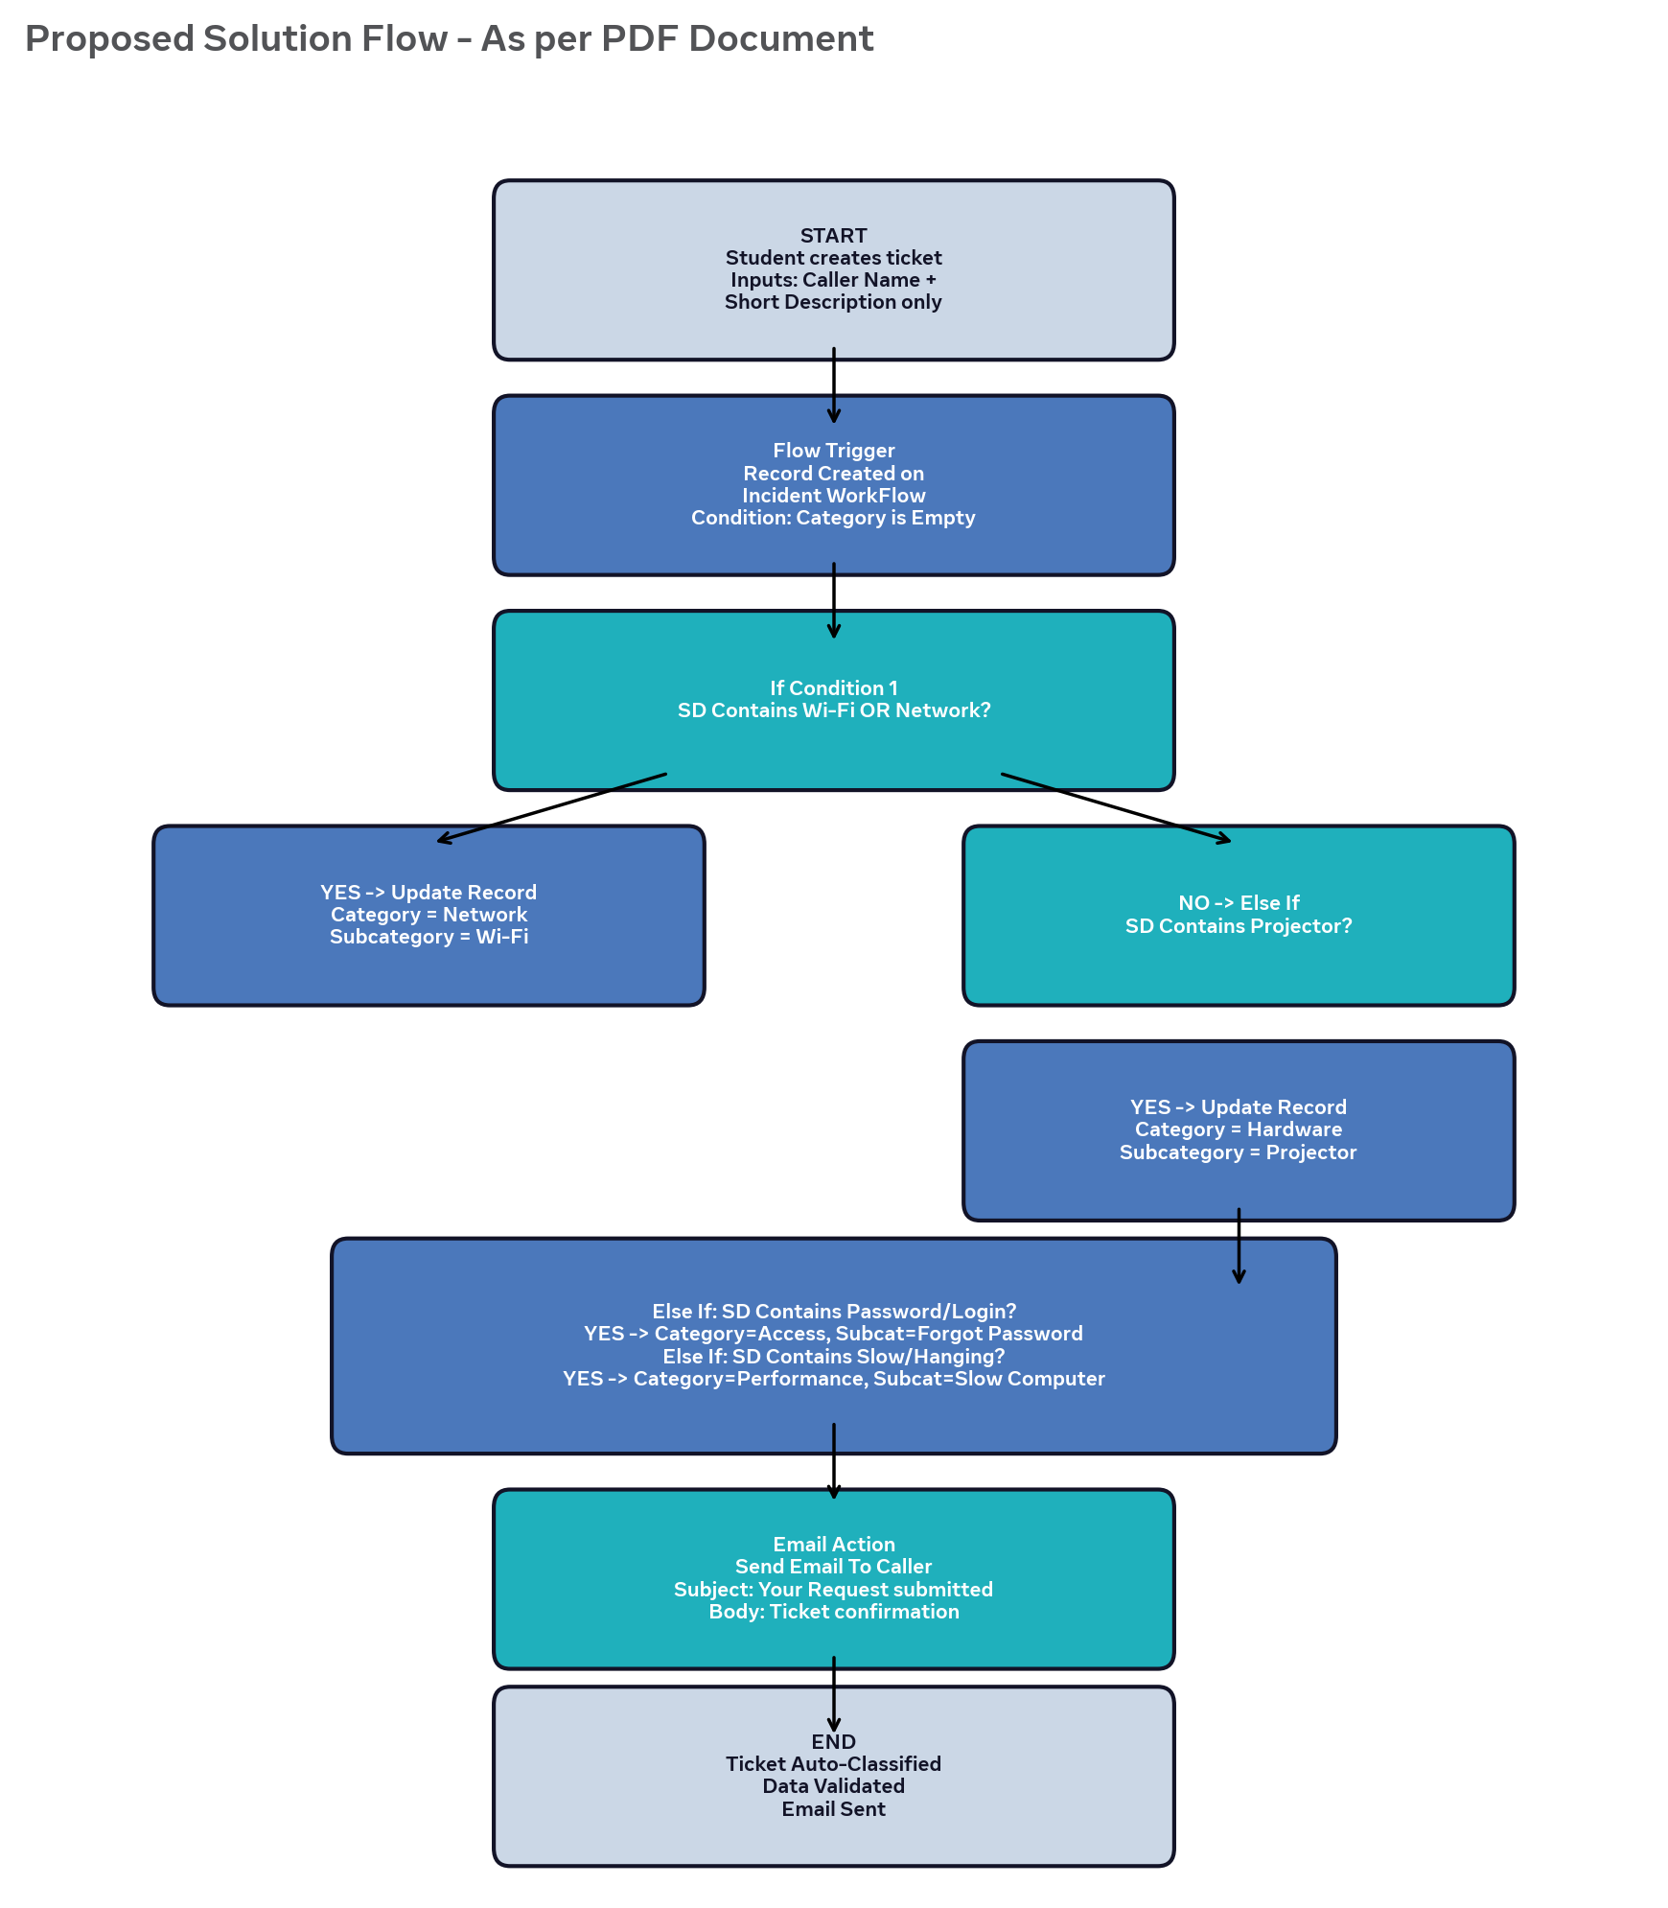

Functional Coverage
Keyword in Short Description | Category Assigned | Subcategory Assigned | Example Input
Wi-Fi, WiFi, Network, Internet | Network | Wi-Fi | WiFi not working in library
Projector, Hardware, Screen | Hardware | Projector | Projector not turning on
Password, Forgot, Login, Access | Access | Forgot Password | Forgot password cannot login
Slow, Hanging, Performance, Lag | Performance | Slow Computer | Computer is slow and hanging

Benefits of Proposed Solution
• Automatically classify incidents at time of creation.
• Reduce manual effort for IT agents.
• Improve ticket routing efficiency.
• Implement no-code, easily maintainable solution.
• Ensure consistent classification and eliminate human error.

